Computer Networks and

Data Communications

(CSCL 3205)

Laboratory Manual

(Spring 2024)

|  |  |  |
| --- | --- | --- |
|  | Student Name: | Sabih Ul Hassan |
| Roll No: | 2112126 |
| Section: | BSCS VI-A |
| **Lab Instructor:**  Idrees Darbar |  |  |

**Experiment# 06**

# Lab6.1-SecurityFeaturesonSwitch

### Topology:

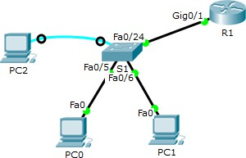

**Objectives:**

Part1:ConfiguregeneralsecurityfeaturesonS1. Part 2: Configure and verify port security on S1.

## ConfigureandVerifySecurityFeaturesonS1

Youwillshutdownunusedports,turnoffcertainservicesrunningontheswitch,andconfigureportsecuritybased on MAC addresses. Switches can be subject to MAC address table overflow attacks, MAC spoofing attacks, and unauthorized connections to switch ports. You will configure port security to limit the number of MAC addresses that can be learned on a switch port and disable the port if that number is exceeded.

**Note:ToimplementingsecurityfeaturesonS1,pleasemakesurethatyoushouldbeestablishedaconsole session or configure security features through console cable.**

#### Step 1: ConfiguregeneralsecurityfeaturesonS1.

1. Configureamessageoftheday(MOTD)banneronS1withanappropriatesecuritywarningmessage.
2. Issuea**showipinterfacebrief**commandonS1.Whatphysicalportsareup?
3. Shutdownallunusedphysicalportsontheswitch.Usethe **interfacerange**command. S1(config)# **interface range f0/1 – 4**

S1(config-if-range)#**shutdown**

S1(config-if-range)#**interfacerangef0/7– 24**

S1(config-if-range)#**shutdown**

S1(config-if-range)#**interfacerangeg0/1–2**

S1(config-if-range)#**shutdown**

S1(config-if-range)#**end**

S1#

1. Issuethe**showipinterfacebrief**commandonS1.WhatisthestatusofportsF0/1toF0/4?

#### Step 2: ConfigureandverifyportsecurityonS1.

1. RecordtheR1G0/1MACaddress.FromtheR1CLI,usethe **showinterfaceg0/1** commandandrecordthe MAC address of the interface.

##### R1#showinterfaceg0/1

GigabitEthernet0/1isup,lineprotocolis up

HardwareisCNGigabitEthernet,addressis30f7.0da3.1821(bia3047.0da3.1821)

WhatistheMACaddressoftheR1G0/1interface?

1. FromtheS1CLI,issuea **showmacaddress-table**commandfromprivilegedEXECmode.Findthedynamic entries for ports F0/5 and F0/6. Record them below.

F0/5 MAC address: F0/6 MACaddress:

1. Configurebasicportsecurity.

**Note**:Thisprocedurewouldnormallybeperformedonallaccessportsontheswitch.F0/5isshownhereasan example.

* 1. FromtheS1CLI, enterinterfaceconfigurationmodefortheportthatconnectstoR1. S1(config)# **interface f0/5**
  2. Shut down the port. S1(config-if)#**shutdown**
  3. Enabletheswitchport.

S1(config-if)#**noshutdown**

S1(config-if)#**end**

* 1. EnableportsecurityonF0/5. S1 (config) # **int fa 0/5**

S1(config-if)#**switchportmodeaccess**

S1(config-if)#**switchportport-security**

S1(config-if)#**switchportport-securitymaximum1**

S1(config-if)#**switchportport-securitymac-address0060.47ed.4873**

S1(config-if)#**switchportport-securityviolationshutdown OR**

S1(config-if)#**switchportport-securityviolationprotect OR**

S1(config-if)#**switchportport-securityviolationRestrict Note**:

* Entering the **switchport port-security** command sets the maximum MAC addresses to 1 and the violationactiontoshutdown.The **switchportport-securitymaximum**and**switchportport-security violation** commands can be used to change the default behavior.
* Therearethreedifferentmodesofviolationintermsofswitchportsecurity
  + 1. **Shutdown:**portwillbeadministrativelyshutdownbecauseofsecurityviolation.
    2. **Protect:**PortremainsactiveaftersecurityviolationoccurbutignorethatrogueMAC-Address
    3. **Restrict:**PortremainsactiveaftersecurityviolationoccurbutignorethatrogueMAC- Address and copy the information to the network monitoring system.
  1. ConfigureastaticentryfortheMACaddressofR1G0/1interfacerecordedinStep2a.

S1(config-if)# switchport port-security mac-address xxxx.xxxx.xxxx (xxxx.xxxx.xxxxistheactualMACaddressoftherouterG0/1interface)

**Note**:Optionally,youcanusethe **switchportport-securitymac-addresssticky**commandtoaddallthesecure MAC addresses that are dynamically learned on a port (up to the maximum set) to the switch running configuration.

1. VerifyportsecurityonS1F0/5byissuinga **showport-securityinterface**command. S1# **show port-security interface f0/5**

PortSecurity : Enabled

Port Status : Secure-up Violation Mode :Shutdown

AgingTime :0mins

Aging Type : Absolute SecureStaticAddressAging:Disabled Maximum MAC Addresses 1

Total MACAddresses 1

ConfiguredMAC Addresses 1

StickyMAC Addresses 0

LastSourceAddress:Vlan:0000.0000.0000:0 Security Violation Count 0

WhatistheportstatusofF0/5?

1. FromR1commandprompt,pingPC-Atoverifyconnectivity.

##### R1#ping172.16.99.3

1. Youwillnowviolate securitybychangingtheMACaddressontherouterinterface.Enterinterface configuration mode for G0/1 and shut it down.

R1#**configt**

R1(config)#**interfaceg0/1**

R1(config-if)#**shutdown**

1. ConfigureanewMACaddressfortheinterface,using **aaaa.bbbb.cccc**astheaddress.

R1(config-if)#**mac-addressaaaa.bbbb.cccc**

1. If possible, have a console connection open on S1 at the same time that you do this step. You will see various messagesdisplayedontheconsoleconnectiontoS1indicatingasecurityviolation.EnabletheG0/1interfaceon R1.

R1(config-if)#**noshutdown**

1. FromR1privilegedEXECmode,pingPC-A.Wasthepingsuccessful?Whyorwhynot?
2. Ontheswitch,verifyportsecuritywiththefollowingcommandsshownbelow. S1# **show port-security**

SecurePortMaxSecureAddrCurrentAddrSecurityViolationSecurityAction (Count) (Count) (Count)

Fa0/5 1 1 1 Shutdown

TotalAddressesin System(excluding onemacperport) :0

MaxAddresseslimitinSystem(excludingonemacperport):8192

##### S1#showport-securityinterfacef0/5

PortSecurity : Enabled

Port Status :Secure-shutdown Violation Mode : Shutdown

AgingTime :0mins

Aging Type : Absolute SecureStaticAddressAging:Disabled

MaximumMAC Addresses 1

Total MACAddresses 1

ConfiguredMAC Addresses 1

StickyMAC Addresses 0

LastSourceAddress:Vlan:aaaa.bbbb.cccc:99 Security Violation Count 1

##### S1#showinterface f0/5

FastEthernet0/5isdown,lineprotocol isdown(err-disabled)

HardwareisFastEthernet,addressis0cd9.96e2.3d05(bia0cd9.96e2.3d05) MTU 1500 bytes, BW 10000 Kbit/sec, DLY 1000 usec,

reliability255/255,txload1/255,rxload1/255

<outputomitted>

##### S1#showport-securityaddress

SecureMacAddress Table

Vlan Mac Address Type Ports RemainingAge

(mins)

99 30f7.0da3.1821SecureConfigured Fa0/5 -

TotalAddressesin System(excluding onemacperport) :0

MaxAddresseslimitinSystem(excludingonemacperport):8192

1. Ontherouter,shutdowntheG0/1interface,removethehard-codedMACaddressfromtherouter,andre- enable the G0/1 interface.

R1(config-if)#**shutdown**

R1(config-if)#**nomac-addressaaaa.bbbb.cccc**

R1(config-if)#**noshutdown**

R1(config-if)#**end**

1. FromR1,pingPC-Aagainat172.16.99.3.Wasthepingsuccessful?
2. OntheSwitch,issuethe **showinterfacef0/5**commandtodeterminethecauseofpingfailure.Recordyour findings.
3. CleartheS1F0/5errordisabledstatus. S1# **config t**

S1(config)#**interfacef0/5**

S1(config-if)#**shutdown**

S1(config-if)#**noshutdown**

**Note**:Theremaybeadelaywhiletheportstatesconverge.

1. Issuethe**showinterfacef0/5**commandonS1toverifyF0/5isnolongerinerrordisabledmode. S1# **show interface f0/5**

FastEthernet0/5 isup,lineprotocolisup(connected)

HardwareisFastEthernet,addressis0023.5d59.9185(bia0023.5d59.9185) MTU 1500 bytes, BW 100000 Kbit/sec, DLY 100 usec,

reliability255/255,txload1/255,rxload1/255

1. FromtheR1commandprompt,pingPC-Aagain.Youshouldbesuccessful.

# Lab6.2–Configuring802.1QTrunk-BasedInter-VLANRouting

### Topology

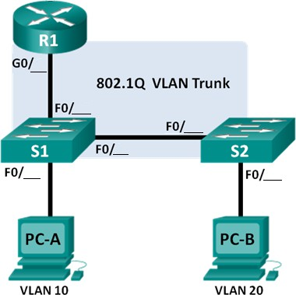

|  |  |  |  |  |
| --- | --- | --- | --- | --- |
| **Device** | **Interface** | **IPAddress** | **SubnetMask** | **DefaultGateway** |
| R1 | G0/0.1 | 192.168.1.1 | 255.255.255.0 | N/A |
|  | G0/0.10 | 192.168.10.1 | 255.255.255.0 | N/A |
|  | G0/0.20 | 192.168.20.1 | 255.255.255.0 | N/A |
| S1 | VLAN1 | 192.168.1.11 | 255.255.255.0 | 192.168.1.1 |
| S2 | VLAN1 | 192.168.1.12 | 255.255.255.0 | 192.168.1.1 |
| PC-A | NIC | 192.168.10.3 | 255.255.255.0 | 192.168.10.1 |
| PC-B | NIC | 192.168.20.3 | 255.255.255.0 | 192.168.20.1 |

**SwitchPortAssignmentSpecifications**

*Table:6.2.1*

|  |  |  |
| --- | --- | --- |
| **Ports** | **Assignment** | **Network** |
| S1F0/ | 802.1QTrunk | N/A |
| S2F0/ | 802.1QTrunk | N/A |
| S1F0/ | 802.1QTrunk | N/A |
| S1F0/ | VLAN10 –Students | 192.168.10.0/24 |
| S2F0/ | VLAN20 –Faculty | 192.168.20.0/24 |

*Table:6.2.1*

### Objectives

**Part1:BuildtheNetworkandConfigureBasicDeviceSettings Part 2: Configure Switches with VLANs and Trunking**

**Part3:ConfigureTrunk-BasedInter-VLANRouting**

### Background/ Scenario

AsecondmethodofprovidingroutingandconnectivityformultipleVLANsisthroughtheuseofan802.1Qtrunk between one or more switches and a single router interface. This method is also known as router-on-a-stick inter- VLAN routing. In this method, the physical router interface is divided into multiple subinterfaces that provide logical pathways to all VLANs connected.

Inthislab,youwillconfiguretrunk-basedinter-VLANroutingandverifyconnectivitytohostsondifferentVLANs as well as with a loopback on the router.

**Note**: This lab provides minimal assistance with the actual commands necessary to configure trunk-based inter- VLANrouting.However,therequiredconfigurationcommandsareprovidedinAppendixAofthislab.Testyour knowledge by trying to configure the devices without referring to the appendix.

**Note**: The routers used with CCNA hands-on labs are Cisco 1941 Integrated Services Routers (ISRs) with Cisco IOS, Release 15.2(4)M3 (universalk9 image). The switches used are Cisco Catalyst 2960s with Cisco IOS, Release 15.0(2)(lanbasek9image).Otherrouters,switchesandCiscoIOSversionscanbeused.Dependingonthemodeland CiscoIOSversion,thecommandsavailableandoutputproducedmightvaryfromwhatisshowninthelabs.Referto the Router Interface Summary Table at the end of the lab for the correct interface identifiers.

**Note**:Makesurethattheroutersandswitcheshavebeenerasedandhavenostartupconfigurations. Ifyouare unsure, contact your instructor.

### RequiredResources

* 1 Router
* 2 Switches
* 2PCs(Windows7,Vista,orXPwithterminalemulationprogram,suchasTeraTerm)
* ConsolecablestoconfiguretheCiscoIOSdevicesviatheconsoleports
* Ethernetcablesasshowninthetopology

## Part1: BuildtheNetworkandConfigureBasicDeviceSettings

InPart1,youwillsetupthenetworktopologyandconfigurebasicsettingsonthePChosts,switches,androuter.

**Step 1: Cablethenetworkasshowninthetopology. Step 2: Configure PC hosts.**

**Step 3: Initializeandreloadtherouterandswitchesasnecessary.**

**Step 4: Configurebasicsettingsforeachswitch.**

1. DisableDNSlookup.
2. Configuredevicenamesasshowninthetopology.
3. Assign**class**astheprivilegedEXECpassword.
4. Assign**cisco**astheconsoleandvtypasswords.
5. Configure**loggingsynchronous**fortheconsoleline.
6. ConfiguretheIPaddresslistedintheAddressingTableforVLAN1onbothswitches.
7. Configurethedefaultgatewayonbothswitches.
8. Administrativelydeactivateallunusedportsontheswitch.
9. Copytherunningconfigurationtothestartupconfiguration.

#### Step 5: Configurebasicsettingsfortherouter.

1. DisableDNSlookup.
2. Configuredevicenamesasshowninthetopology.
3. ConfiguretheLo0IPaddressasshownintheAddressTable.Donotconfiguresubinterfacesatthistimeasthey will be configured in Part 3.
4. Assign**cisco**astheconsoleandvtypasswords.
5. Assign**class**astheprivilegedEXECpassword.
6. Configure**loggingsynchronous**topreventconsolemessagesfrominterruptingcommandentry.
7. Copytherunningconfigurationtothestartupconfiguration.

## Part2: ConfigureSwitcheswithVLANsandTrunking

InPart2,youwillconfiguretheswitcheswithVLANsandtrunking.

**Note**:TherequiredcommandsforPart2areprovidedinAppendixA.Testyourknowledgebytryingtoconfigure S1 and S2 without referring to the appendix.

#### Step 1: ConfigureVLANsonS1.

1. OnS1,configuretheVLANsandnameslistedintheSwitchPortAssignmentSpecificationstable.Writethe commands you used in the space provided.
2. OnS1,configuretheinterfaceconnectedtoR1asatrunk.AlsoconfiguretheinterfaceconnectedtoS2asa trunk. Write the commands you used in the space provided.
3. OnS1,assigntheaccessportforPC-AtoVLAN10.Writethecommandsyouusedinthespaceprovided.

#### Step 2: ConfigureVLANsonSwitch2.

1. OnS2,configuretheVLANsandnameslistedintheSwitchPortAssignmentSpecificationstable.
2. OnS2,verifythattheVLANnamesandnumbersmatchthoseonS1.Writethecommandyouusedinthespace provided.
3. OnS2,assigntheaccessportforPC-BtoVLAN20.
4. OnS2,configuretheinterfaceconnectedtoS1asatrunk.

## Part3: ConfigureTrunk-BasedInter-VLANRouting

InPart3,youwillconfigureR1toroutetomultipleVLANsbycreatingsubinterfacesforeachVLAN.Thismethod of inter-VLAN routing is called router-on-a-stick.

**Note**:TherequiredcommandsforPart3areprovidedinAppendixA.Testyourknowledgebytryingtoconfigure trunk-based or router-on-a-stick inter-VLAN routing without referring to the appendix.

#### Step 1: ConfigureasubinterfaceforVLAN1.

1. CreateasubinterfaceonR1G0/1forVLAN1using1asthesubinterfaceID.Writethecommandyouusedin the space provided.
2. ConfigurethesubinterfacetooperateonVLAN1.Writethecommandyouusedinthespaceprovided.
3. ConfigurethesubinterfacewiththeIPaddressfromtheAddressTable.Writethecommandyouusedinthe space provided.

#### Step 2: ConfigureasubinterfaceforVLAN10.

1. CreateasubinterfaceonR1G0/1forVLAN10using10asthesubinterfaceID.
2. ConfigurethesubinterfacetooperateonVLAN 10.
3. ConfigurethesubinterfacewiththeaddressfromtheAddressTable.

#### Step 3: ConfigureasubinterfaceforVLAN20.

1. CreateasubinterfaceonR1G0/1forVLAN20using20asthesubinterfaceID.
2. ConfigurethesubinterfacetooperateonVLAN 20.
3. ConfigurethesubinterfacewiththeaddressfromtheAddressTable.

#### Step 4: EnabletheG0/0 interface.

EnabletheG0/0interface.Writethecommandsyouusedinthespaceprovided.

#### Step 5: Verifyconnectivity.

EnterthecommandtoviewtheroutingtableonR1.Whatnetworksarelisted?

From PC-A, is it possible to ping the default gateway for VLAN 10? From PC-A, is it possible to ping PC-B?

From PC-A, is it possible to ping Lo0? From PC-A, is it possible to ping S2?

Iftheansweris**no**toanyofthesequestions,troubleshoottheconfigurationsandcorrectanyerrors.

### Reflection

Whataretheadvantagesoftrunk-basedorrouter-on-a-stickinter-VLANrouting?

### AppendixA–ConfigurationCommands

**SwitchS1**

S1(config)#**vlan10**

S1(config-vlan)#**nameStudents** S1(config-vlan)# **vlan 20** S1(config-vlan)# **name Faculty** S1(config-vlan)# **exit** S1(config)# **interface f0/**

S1(config-if)#**switchportmodetrunk**

S1(config-if)#**exit**

S1(config)# **interface f0/** S1(config-if)#**switchportmodetrunk** S1(config-if)# **exit**

S1(config)#**interfacef0/**

S1(config-if)# **switchport mode access** S1(config-if)#**switchportaccessvlan10** S1(config-if)# **exit**

### SwitchS2

S2(config)#**vlan10**

S2(config-vlan)#**nameStudents** S2(config-vlan)# **vlan 20** S2(config-vlan)# **name Faculty** S2(config-vlan)# **exit** S2(config)# **interface f0/**

S2(config-if)#**switchportmodetrunk**

S2(config-if)#**exit**

S2(config)#**interfacef0/**

S2(config-if)# **switchport mode access** S2(config-if)#**switchportaccessvlan20** S2(config-if)# **exit**

### RouterR1

R1(config)# **interface g0/0** R1(config-if)#**noipaddress** R1(config-if)# **no shutdown** R1(config-if)# exit R1(config)#**interfaceg0/0.1**

R1(config-subif)#**encapsulationdot1Q1**

R1(config-subif)#**ipaddress192.168.1.1255.255.255.0**

R1(config-subif)# exit R1(config)#**interfaceg0/0.2**

R1(config-subif)#**encapsulationdot1Q10**

R1(config-subif)#**ipaddress192.168.10.1255.255.255.0**

R1(config-subif)# exit R1(config)#**interfaceg0/0.3**

R1(config-subif)#**encapsulationdot1Q20**

R1(config-subif)#**ipaddress192.168.20.1255.255.255.0**

R1(config-subif)#**exit**

# Lab6.3–HomeActivity

Inthelightofaboveexperiments,Configurethefollowingtopologybyusingaddressingtable,VLAN andport assignment table. Also implement the port security features on all the switch ports.

### Scenario

SupposeyouaredesigningasmallVLANswitchednetwork withinterVLANrouting forthreefloorsofSZABIST100 campus.

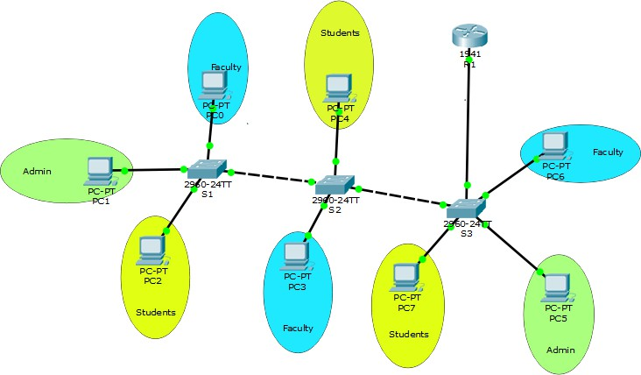

*Fig:6.3.1*

### AddressingTable:

|  |  |  |  |  |
| --- | --- | --- | --- | --- |
| **Device** | **Interface** | **IPAddress** | **SubnetMask** | **DefaultGateway** |
| PC0 | NIC | 192.168.1.2 | 255.255.255.0 | 192.168.1.1 |
| PC3 | NIC | 192.168.1.3 | 255.255.255.0 | 192.168.1.1 |
| PC6 | NIC | 192.168.1.4 | 255.255.255.0 | 192.168.1.1 |
| PC1 | NIC | 192.168.2.2 | 255.255.255.0 | 192.168.2.1 |
| PC5 | NIC | 192.168.2.3 | 255.255.255.0 | 192.168.2.1 |
| PC2 | NIC | 192.168.3.3 | 255.255.255.0 | 192.168.3.1 |
| PC4 | NIC | 192.168.3.3 | 255.255.255.0 | 192.168.3.1 |
| PC7 | NIC | 192.168.3.3 | 255.255.255.0 | 192.168.3.1 |
| R1 | G0/0.1 | 192.168.1.1 | 255.255.255.0 | N/A |
|  | G0/0.2 | 192.168.2.1 | 255.255.255.0 | N/A |
|  | G0/0.3 | 192.168.3.1 | 255.255.255.0 | N/A |

*Table:6.3.1*

### VLANsandPortsAssigning Table:

|  |  |  |  |  |  |
| --- | --- | --- | --- | --- | --- |
| **VLANs** | **Name** | **SwitchportNumber** | | | |
| **AccessPorts** | | **TrunkPorts** | |
| 2 | Faculty | S1 | fa0/1–fa0/5 | S1 | FastEthernet 0/24 |
| S2 | fa0/18– fa0/22 |
| S3 | fa0/18– fa0/23 |
| 3 | ADMIN | S1 | fa0/6–fa0/12 | S2 | FastEthernet0/23 FastEthernet 0/24 |
| S2 |  |
| S3 | fa0/14– fa0/17 |
| 4 | Students | S1 | fa0/13– fa0/23 | S3 | FastEthernet 0/24 |
| S2 | fa0/1–fa0/17 |
| S3 | fa0/1–fa0/13 |

*Table:6.3.2*

***Note:***

* Putthescreen shotof yourdesigned topologyat theend ofthis experiment.
* Alsoattachthescreen shots ofstartupconfigurations ofeach networkdevices.

**Lab’sEvaluationSheet**

|  |  |
| --- | --- |
| **StudentsRegistrationNo:** | 2112126 |
| **Date Performed:** | 5/9/24 |
| **GroupNo:** |  |
| **DateofSubmission:** |  |

|  |  |  |  |
| --- | --- | --- | --- |
| **Sr.No.** | **Categories** | **Total Marks/Grade** | **Marks /Grade**  **Obtained** |
| **1** | **Student’s Behavior** | **2.5** |  |
| **2** | **LabPerformance** | **2.5** |  |
| **3** | **OnTime Submission** | **5** |  |
| **4** | **Home Activity** | **10** |  |
|  | **NetResult** | **20** |  |



ExaminedBy:(Instructor’sName&Initial’s) Date

# TOPOLOGY

# 

# VLANS

Sabih_1

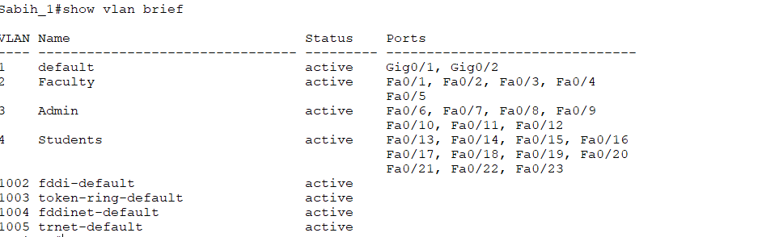

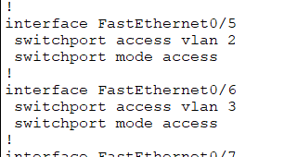 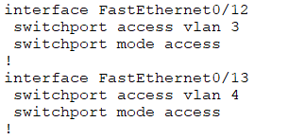

Sabih_2

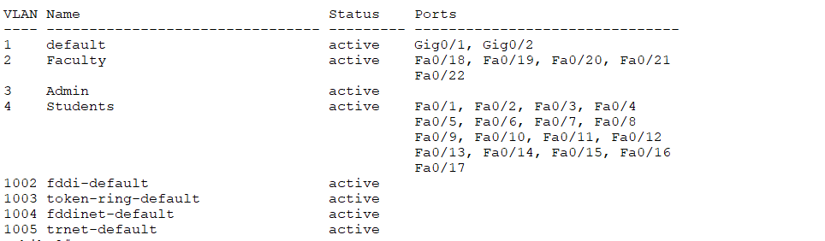

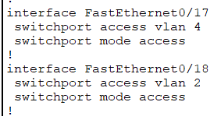

Sabih_3

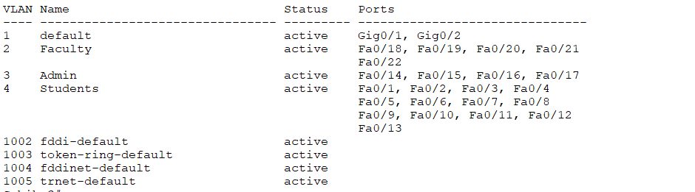

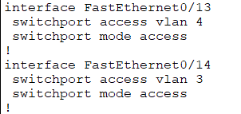 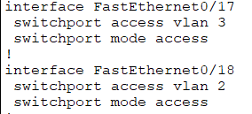

# PING

